**CANDIDATES NAME:…………………………………………………………………………..**

|  |  |  |  |  |  |  |  |
| --- | --- | --- | --- | --- | --- | --- | --- |
| **INDEX NUMBER** | | | | | | | |
|  |  |  |  |  |  |  |  |

**SIGNATURE: ……………………………………**

**456/2**

**MATHEMATICS**

**PAPER 2**

**JUNE/JULY**

**2 HOURS**

**MOCK EXAMINATIONS SET 1 2019**

**Uganda Certificate of Education**

**MATHEMATICS**

PAPER 2

2 HOURS

**INSTRUCTIONS TO CANDIDATES:**

* *Answer all questions in section A and any five questions from section B.*
* *Any additional question (s) answered will not be marked.*
* *All necessary calculations must be done on the same answer booklet provided. Therefore, no paper should be given for rough work.*
* *Mathematical tables and squared papers may be provided.*
* *Silent, non-programmable scientific calculators and mathematical tables with a list of formulae may be used.*
* *State the degree of accuracy at the end of each question attempted using calculator or mathematical table and indicate Cal for calculator or Tab for mathematics tables.*

**SECTION A: (40 MARKS)**

1. Express 0.52777 ... as a fraction in its lowest term. (4 marks)

2. Given that  Find:

i) The value of P (2 marks)

ii) The length of P (2 marks)

3. If f**-1** (x) = 2x**2** – 3, find

i) An expression for f(x)

ii) f(15) (4 marks)

4. A car travelled at an average speed of 85kmh**-1** for 5 hours and then it further travelled at an average speed of 69kmh**-1** for 3 hours. Find the average speed of the car for the whole journey. (4 marks)

5. Simplify; 2log**10**5 - log**10**0.1 + log**10**4. (4 marks)

6. Express,  in the form a + b where a, b and c are integers.

(4 marks)

7. Maido bought a printing machine at Shs 7,000,000. The depreciation rate of the machine is 14.0% per annum. Calculate the value of the machine after 2 years. (4 marks)

8. Make X the subject of the formula.

 (4 marks)

9. In the triangle ABC below, AT is perpendicular to BC, angle ABT = 25°.

AT = TC and AC = 10cm. Find the length of . (4 marks)

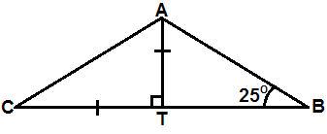

10. P varies as the square of V and inversely as R. How is P affected when V is decreased by 10% and R is increased by 20%. (4 marks)

**SECTION B: (60 MARKS)**

11. a) Given that F(x) = 4x – 3, find

i) f(2)

ii) f**-1**(x)

iii) f**-1**(-1) (6 marks)

b) Given that f(x) = x2 + 1 and h(x) = x – 3, find the value of x for which gh(x) = hg(x). (6 marks)

12. Ogooro and Okwir wish to travel to the next trading center which is 30.8km away. They will travel by their bicycles. When Ogooro had covered 9km, travelling steadily at 4kmh**-1**, Okwir started riding at a steady speed of 7kmh**-1** from where Ogooro started. Both Okwir and Ogooro maintained their cycling speeds until Okwir overtook him.

a) Find the time and distance at which Okwir overtook Ogooro.

b) Given that Okwir then reduced his speed and maintained the new speed till he arrived at the trading center, thereby arriving 0.6 hours later than if he had maintained the 7kmh**-1** speed.

i) Calculate by how much he reduced his speed

ii) For how long was he in the trading center before Ogooro joined him?

13. 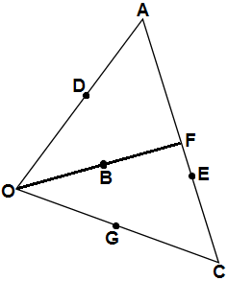

In The figure above B, D, E and G are mid points of OF, OA, AC and OC respectively.

AF: FE = 2:3, if OA = a and OB = 6

a) Express the following vectors in terms of a and b.

i) AF

ii) AE

iii) AC

iv) OC

v) DG

b) Show that D, B and G are collinear.

14. 56 people went on holiday to Mombasa. They had trips by boat (B), coach (C), or helicopter (H). 32 went on a coach, 32 went of boat, 10 went by helicopter, 12 went on the boat trip and coach but not helicopter, 14 went by boat and helicopter but not the coach trip, two went by coach and helicopter but not by boat, eight did not take any of the above trips.

a) Draw a Venn diagram to represent the above information.

b) Find the number of people who;

i) Used all the three

ii) Did not use any of the three means.

c) Write down the value of n[(BUC)nH]. (12 marks)

15. a) A map has a scale of 1:250,000. The area of the swamp on the map is 12cm**2**. What is the actual area of the swamp in km**2**? (5 marks)

b) In a business John gets a fixed pay of Shs 80,000 and Daniel gets

Shs 60,000 per month. The remainder is shared among John, Daniel and Tom in the ratio 2:3:5 respectively. At the end of a certain month the business made Shs 480,000. Determine the amount each got from the business. (7 marks)

16. A quantity R varies partly as the square of V and partly as the cube of V,when

V = 20, R = 416 and when V = 40, R = 3264.

a) Form an equation relating R and V.

b) Determine the value of R when V = 30. (12 marks)

17. 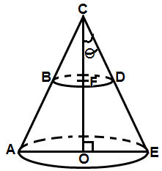

ABCDE is a right solid cone. CE = 10cm, θ = 30°, CD: DE = 2:3. The cone BCD was cut off.

Calculate the:

i) total surface area of the remaining portion ABDE

ii) volume of the cone BCD. (12 marks)

**END**